**Q1.**

Rory is talking with his grandparent and playing a game on his phone at the same time. The game involves matching blocks of the same colour to complete vertical and horizontal lines. It is only when his grandparent asks him to describe his route to school that Rory puts down his game so he can concentrate fully on his answer.

Discuss the working memory model. Refer to Rory’s behaviour in your answer.

**(Total 16 marks)**

**Q2.**

A brain scan shows that one area of the brain is more active when a person is doing a verbal task. However, when this person is doing a visual task, a different area of the brain is more active.

(a)     Explain how this could relate to the working memory model. Refer to different  
parts of the working memory model in your answer.

**(4)**

(b)     Give an example of an appropriate verbal task and an appropriate visual task  
which could be used during the brain scan.

**(2)**

**(Total 6 marks)**

**Q3.**

Explain **one** strength **and** **one** weakness of the working memory model.

**(Total 4 marks)**

**Q4.**

Tick **two** of the boxes below to indicate which of the following are features of the working memory model.

|  |  |  |
| --- | --- | --- |
| **A** | Serial position curve |  |
| **B** | Incidental learning store |  |
| **C** | **C**entral executive |  |
| **D** | Phonological loop |  |

**(Total 2 marks)**

**Q5.**

Explain **one** limitation of the working memory model.

**(Total 2 marks)**

**Q6.**

Outline and evaluate the working memory model.

**(Total 12 marks)**

**Q7.**

Outline and evaluate the working memory model.

**(Total 16 marks)**

**Q8.**

Outline the working memory model.

**(Total 4 marks)**

**Q9.**

Choose **one** study of the working memory model. Briefly outline what the participants were asked to do in this study.

**(Total 2 marks)**

**Q10.**

Explain **one** strength of the working memory model.

**(Total 3 marks)**

**Q11.**

Outline **two** features of the working memory model.

**(Total 2 marks)**

**Q12.**

Outline **one** strength and **one** limitation of the working memory model.

**(2)**

**(2)**

**(Total 4 marks)**

**Q13.**

Outline the main features of the working memory model.

**(Total 4 marks)**

**Q14.**

An experiment was carried out to investigate the working memory model.

One group of participants was asked to carry out two visual tasks at the same time. A different group of participants was asked to carry out a visual task and a verbal task at the same time.

The results showed that the participants who carried out two visual tasks at the same time performed less well on the tasks than participants who carried out a visual task and a verbal task at the same time.

Use your knowledge of the working memory model to explain this finding.

**(Total 3 marks)**

**Q15.**

Three components of the working memory model are the central executive, the phonological loop and the visuo-spatial sketchpad.

Briefly outline **each** of these components.

**(Total 6 marks)**

**Q16.**

Claire can search through family photos on her laptop and listen to music at the same time. However, she finds it difficult to read her e-mails when talking to a friend on the phone.

Use your knowledge of the working memory model to explain why Claire is able to perform the first two tasks at the same time, but finds it difficult to perform the second two tasks at the same time.

**(Total 4 marks)**

**Q17.**

Briefly describe the working memory model.

**(Total 4 marks)**

**Q18.**

Bryan has been driving for five years. Whilst driving, Bryan can hold conversations or listen to music with little difficulty.

Bob has had four driving lessons. Driving requires so much of Bob’s concentration that, during lessons, he often misses what his driving instructor is telling him.

With reference to features of the working memory model, explain the different experiences of Bryan and Bob.

**(Total 4 marks)**

**Q19.**

Describe **and** evaluate the working memory model of memory.

**(Total 16 marks)**

**Q20.**

Below is a diagram of the working memory model. Write the name of **each** of the **four** components of working memory in the space provided.

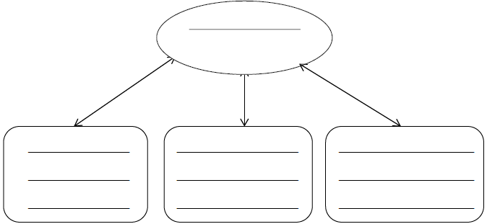

**(Total 4 marks)**

**Q21.**

Discuss what psychological research has shown about working memory.

In your answer, refer to theory and/or evidence.

**(Total 12 marks)**

**Q22.**

Discuss **one** strength of the working memory model.

**(Total 4 marks)**

**Q23.**

Describe the cognitive interview.

**(Total 6 marks)**

**Q24.**

A researcher investigated the working memory model using a laboratory experiment. Forty students from a local college volunteered to take part.

In **Condition A**, 20 students performed the following two tasks at the same time:

•   mentally counting backwards from 100

•   tracking coloured shapes on a computer screen.

In **Condition B**, 20 different students performed the following two tasks at the same time:

•   mentally counting backwards from 100

•   reading a poem out loud.

The researcher predicted that the performance of students in **Condition A** would be better than the performance of students in **Condition B**.

(a)     Name the **two** components of working memory that would be involved in the performance of the tasks in **Condition A**.

**(2)**

(b)     Briefly explain **two** ways in which the working memory experiment described above could be improved.

**(4)**

**(Total 6 marks)**

**Q25.**

Suggest **one** way in which the working memory model might be a better explanation of short-term memory than the multi-store model.

**(Total 1 mark)**

**Q26.**

Apart from the central executive, name and briefly outline **two other** components of the working memory model.

**(Total 4 marks)**

**Q27.**

Evaluate the central executive as part of the working memory model.

**(Total 4 marks)**

**Q28.**

Describe the working memory model.

**(Total 4 marks)**

**Q29.**

Describe the phonological loop component of the working memory model.

**(Total 3 marks)**

**Q30.**

Explain **one** limitation of the working memory model.

**(Total 3 marks)**